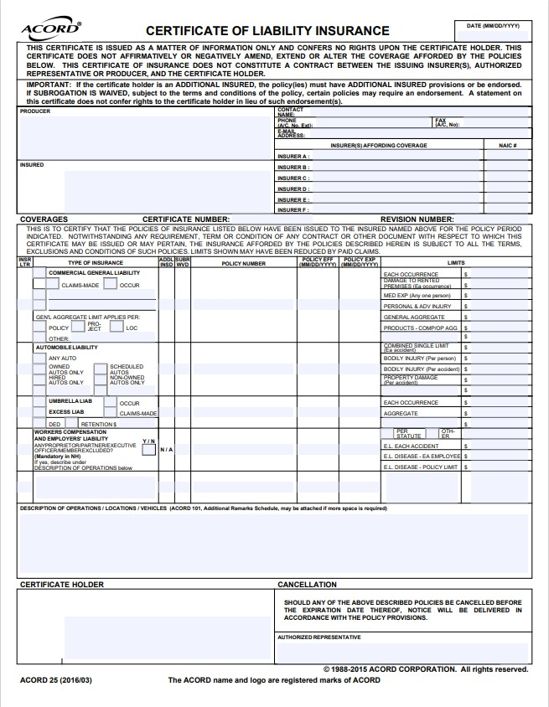

# Example of:

Current year

Each Occurrence

$1,000,000

General Aggregate

$1,000,000

**City of Lemoore**

**711 W. Cinnamon Dr.**

**Lemoore, CA 93245**

�

# Renter Guidelines

Please use this list as a timeline and to ensure proper planning of your event.

It is the renter’s responsibility to provide all items on or before requested due date(s).

 **Signed Contract/Permit:** Renter is to sign on the day rental is booked.

 **Deposit:** See Current Master User Fee Schedule for Amount. Refunded within 4-6 weeks after the event, provided there is no damage and is left clean. Additional fees may be deducted from your deposit.

 **Balance:** Must be paid no later the 30 days prior to event date.

 **Security Company Contract:** Rental(s) with alcohol and/or 50 or more guests are required to have security present. Renter’s responsible for providing a copy of the security contract to the City of Lemoore Parks and Recreation Department located at 721 W. Cinnamon Dr., Lemoore, CA 93245 or email [parksandrecreation@lemoore.com](mailto:parksandrecreation@lemoore.com) 30 days prior to event. *See attached list of City approved security companies. Please note that one security guard is required for every 50 guests.*

 **Alcohol Permit:** Issued by City of Lemoore Parks and Recreation after security contract is received.

 **Liability Insurance:** Required for all renters. Agencies may provide a valid certificate no less than 30 days prior to the event. The amount required is $1 million per occurrence and $1 million for general aggregate. Renter’s responsible for providing a copy of the certificate of liability insurance to the City of Lemoore Parks and Recreation Department.

 **Event Layout:** Due within one week minimum prior to event.

 **City Rollaway Trash Bins: (outdoor events only):** Renter is responsible for submitting trash bin order with a receipt from the City of Lemoore Public Works Dept.) to City of Lemoore Parks and Recreation Department

* **Vendors:** If Vendors (both food and non-food) will be part of the event, it is the responsibility of the Renter to ensure each Vendor has an active City of Lemoore Business License. Renter is also responsible for complying with Kings County Department of Public Health requirement to obtain a permit if food vendors will be present as part of a community or special event in which food or beverage items will be sold. Please visit the following website for more information: https://www.kcdph.com/_files/ugd/39ee12_f43595c8f3b84842b0b5a45624a72cc5.pdf

# City of Lemoore Approved Security Companies w/ Current City Business License

Security guards will be required for any event with alcohol and/or 50 or more guests held in city facilities or public grounds. The number of guards is based on the number of people attending an event (1) GUARD PER 50 GUESTS.

MCSA Private Security

Visalia, CA

(559) 302-7459

AAA Security

Farmersville, CA

(559) 738-5025

# Event Liability Insurance

All renters are required to obtain Event Insurance on their own.

Website: <http://www.eventinsure.com/>

Renters must provide a valid certificate of insurance no less than 30 days prior to event.

**Amount required is $1 million per occurrence and $1 million for general aggregate.**

Please apply at your earliest convenience and submit Certificate of Liability Insurance to

## City of Lemoore Parks and Recreation Department, 721 W. Cinnamon Dr., Lemoore, CA 93245

**or email a copy to parksandrecreation@lemoore.com**

*See attached example of Certificate of Liability Insurance*